Creating a Linux VM

In this disks blade, added a data disk of 4 GB

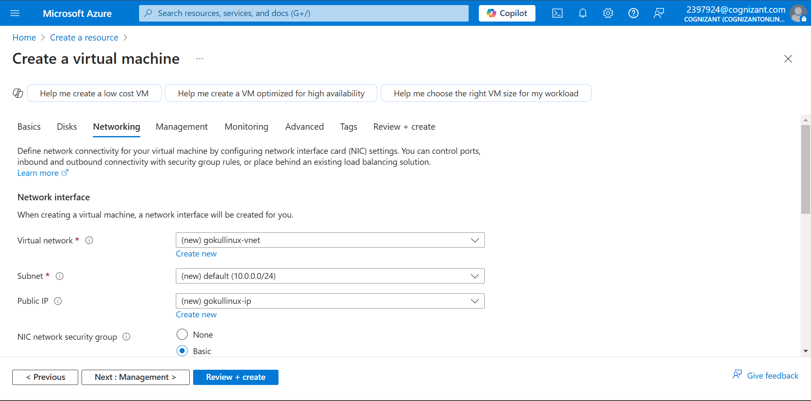

Network Options

Successfully created Linux VM

Using Powershell

Using VNET and Subnet

Public IP Created

Creating a Network Security Group

Creating an NIC

VM Created.